Ralston House Pinwheel Campaign - Help Kids

Dear Friends and Colleagues:

 | 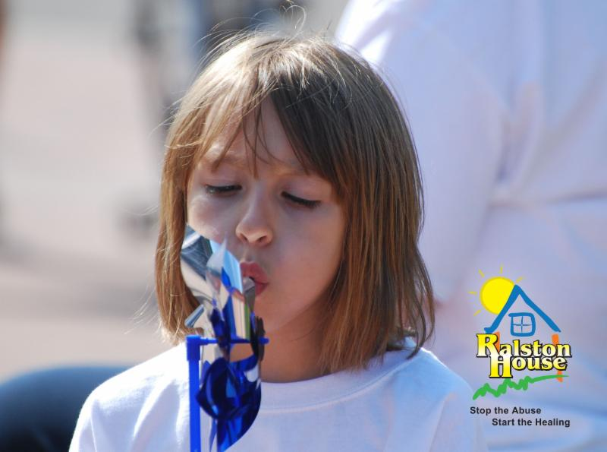
The staff at Ralston House recognizes that this is an unprecedented time for everyone - a time that, for many, is filled with uncertainty. Ralston House continues to provide services to children and families in our communities, to help stop the abuse and start the healing.

As a Board Member, I support Ralston House and I encourage you to help our community's children by supporting this non-profit agency that works tirelessly for children who have been abused, sexually, physically and emotionally. Specially trained staff at Ralston House works with police departments and social services to investigate child abuse and human trafficking.

April is Child Abuse Prevention Month and you can help by making a donation of $5 or more to sponsor pinwheels in our virtual garden.

Details and information: https://www.ralstonhouse.org/pinwheels

However you choose to support Ralston House, know that your gift is greatly appreciated.

Thank you very much,
Board Member
Ralston House

Over 1,000 pinwheels will be planted in honor of children who were brave and shared their story with us last year.

